Exercise C Result

1. I followed instructions and run the programs:

First Trial:

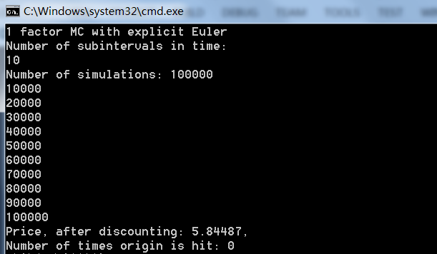

1. For Batch 1 (T=0.25, K=65, sig=0.3, r=0.008, S=60)

|  |  |  |  |
| --- | --- | --- | --- |
| NT | NSIM | C | P |
| 100 | 1000 | 2.14877 | 5.88702 |
| 1000 | 1000 | 2.10416 | 6.0248 |
| 1000 | 10000 | 2.12827 | 5.93043 |
| 1000 | 100000 | 2.13874 | 5.86757 |
| 1000 | 500000 | 2.13291 | 5.84255 |

Exact C=2.1329, P=5.8458

For Batch 2 (T=1.0, K=100, sig=0.2, r=0, S=100):

|  |  |  |  |
| --- | --- | --- | --- |
| NT | NSIM | C | P |
| 100 | 1000 | 7.99503 | 8.04441 |
| 1000 | 1000 | 7.68701 | 8.15226 |
| 1000 | 10000 | 7.90417 | 8.09396 |
| 1000 | 100000 | 7.96180 | 7.99353 |
| 1000 | 500000 | 7.96446 | 7.95713 |

Exact C=7.9663, P=7.9663

Generally at least 1000 time steps and 500000 draws would be needed to get accuracy of 4 decimal places

1. For Batch 4 (T=30, K=100, sig=0.3, r=0.08 S=100)

|  |  |  |  |
| --- | --- | --- | --- |
| NT | NSIM | C | P |
| 100 | 1000 | 92.7150 | 1.3291 |
| 1000 | 1000 | 87.3424 | 1.27867 |
| 1000 | 10000 | 90.5849 | 1.28144 |
| 1000 | 100000 | 92.3483 | 1.25723 |
| 1000 | 500000 | 91.9491 | 1.24841 |

Exact C=92.1749, P=1.24651

We need at least 1000 NT and 500000 NSIM to achieve two decimal point accuracy.

As we illustrate above, Euler method and Monte Carlo Method is not efficient.